Softwaretechnik Projekt WS21/22, Jakob Czekansky

User Guide Hardware
Pick-by-Light
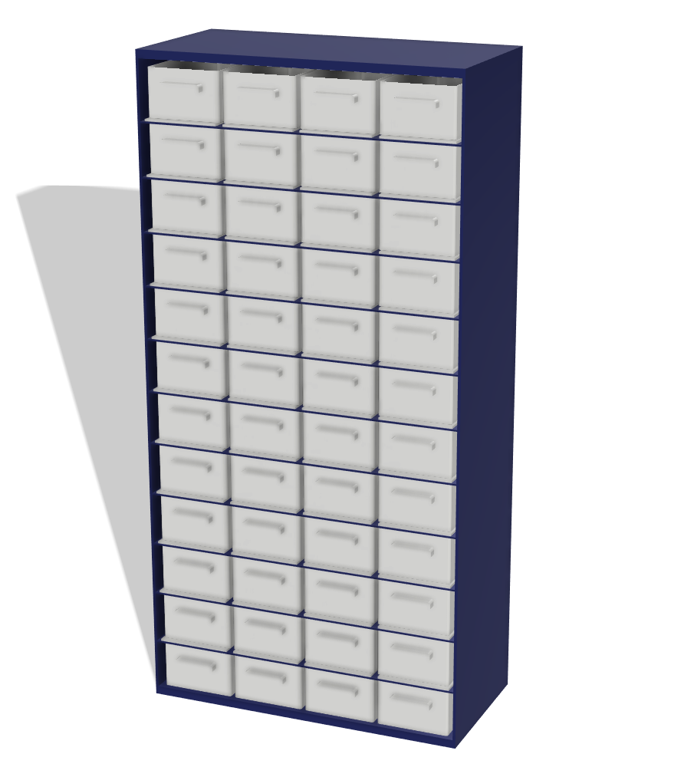

Contents
Introduction 1
Parts List 2
Technical Specifications 3
Used hardware 3
Wiring Diagram 3
Power Consumption 3
Assembly Guide 5
Soldering the LEDs 5
Installation of LEDs to holding mechanisms 5
Assembly and attachment of acrylsheets and installing the holding mechanisms to the sparepartscontainer 6
Testing 7

Introduction

Welcome to the Pick-By-Light system!

The Pick-By-Light System (hereinafter called PBL) is a system to assist you in finding spareparts in multiple rooms and small parts magazin in them. To achieve this the PBL provides a graphical user interface on your smart device or web browser in which you search for a specific sparepart. The compartment, in which the part is stored, will light up.
This project is an open source project and we highly encourage you to build it on your own and modify the hard- or software to your likings. To ensure you are able to do this you will find all relevant information on which parts you need to build it on your own, the technical specifications and an assembly guide in this document.
Some of the parts need to be 3D printed, you can find all necessary 3D printable master files in the git repository.

Parts List

A list of parts needed to build the PBL on your own. This listing is specified for a single sparepartscontainer with 12 rows and 4 compartments per row. 3D printed parts are marked with „(3DP)“.

ItemNr | Description | Qty. | Length (if needed)
1 | Sparepartscontainer | 1
2 | ESP32 Microcontroller | 1
3 | Adafruit Flora Smart NeoPixel (or similar) | 48
4 | (3DP) LED Holding Mechanism | 12
5 | (3DP) LED Wedges | 48
6 | (3DP) LED Holding Mechanism Connector | 22
7 | (3DP) ESP Box | 1
8 | (3DP) ESP Box Lid | 1
9 | 10mm x 3mm Neodym Magnets | 60
10 | Acrylic glass sheets 1,5mm thickness (7cm x 14cm) * | 24
11 | Acrylic glass sheets wedged 1,5mm thickness (7cm x 14cm front, 3cm x 14cm back) * | 24
12 | Cable 1mm diameter (between LEDs) | 108 | 8cm
13 | Cable 1mm diameter (connectors end of row) | 72 | 3cm
14 | Cable 1mm diameter (connector between rows) | 36 | 30cm
15 | JST Male 3 pole | 23
16 | JST Female 3 pole | 24
17 | JST Crimpcontacts | 72
18 | Jumpercable Male (ESP32 connector) | 3 | 10cm

*specific measurements depend on your sparepartscontainer, the acrylic glass sheets need to lay flat underneath each drawer.

Technical Specifications

The PBL is powered by an ESP32 microcontroller to which the LEDs are connected. One ESP32 corresponds to one sparepartscontainer, multiple ESP32s are connected via WIFI to a single Raspberry Pi which holds the Frontend and Backend software structures.

In the following datasheet only the hardware components of one sparepartscontainer will be discussed.

Used hardware

Microcontroller: ESP32
LEDs: Adafruit Flora Smart NeoPixel RGB LED v2 (WS2812B controller)

Wiring Diagram
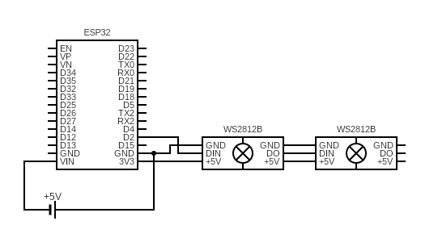

Power Consumption

One NeoPixel draws a maximum of 60mA if all color values are at 100%.
One sparepartscontainer with 48 compartments and so 48 LEDs draws a total of 2,9A at 3,3V.

Depending on how many compartments and LEDs you have per sparepartscontainer you can either power the whole system via the ESP32's pins (as shown in the above wiring diagram) or via a seperate powersupply. If you use the latter option make sure the ESP32 and the LEDs are connected to the same GROUND.

To find a suitable powersupply you can calculate the maximum power consumption of your sparepartscontainer with following formula:

60mA x (NumberOfLEDs) = Powerdrawage

The PBL system can only be powered by a maximum of 5V DC.

For further explanation of power consumption consult the adafruit website:
https://learn.adafruit.com/adafruit-neopixel-uberguide/powering-neopixels

Assembly Guide

Soldering the LEDs
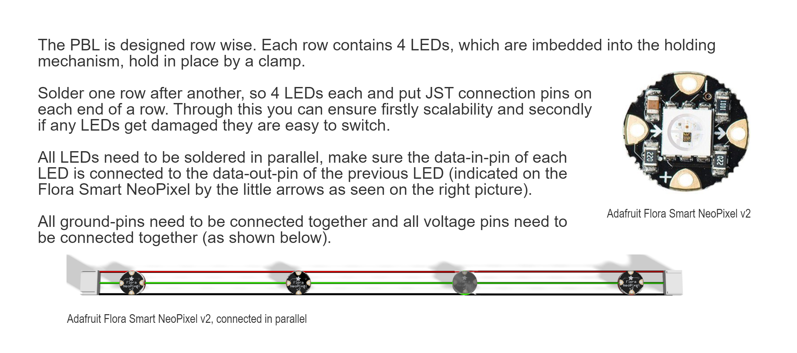

Installation of LEDs to holding mechanisms
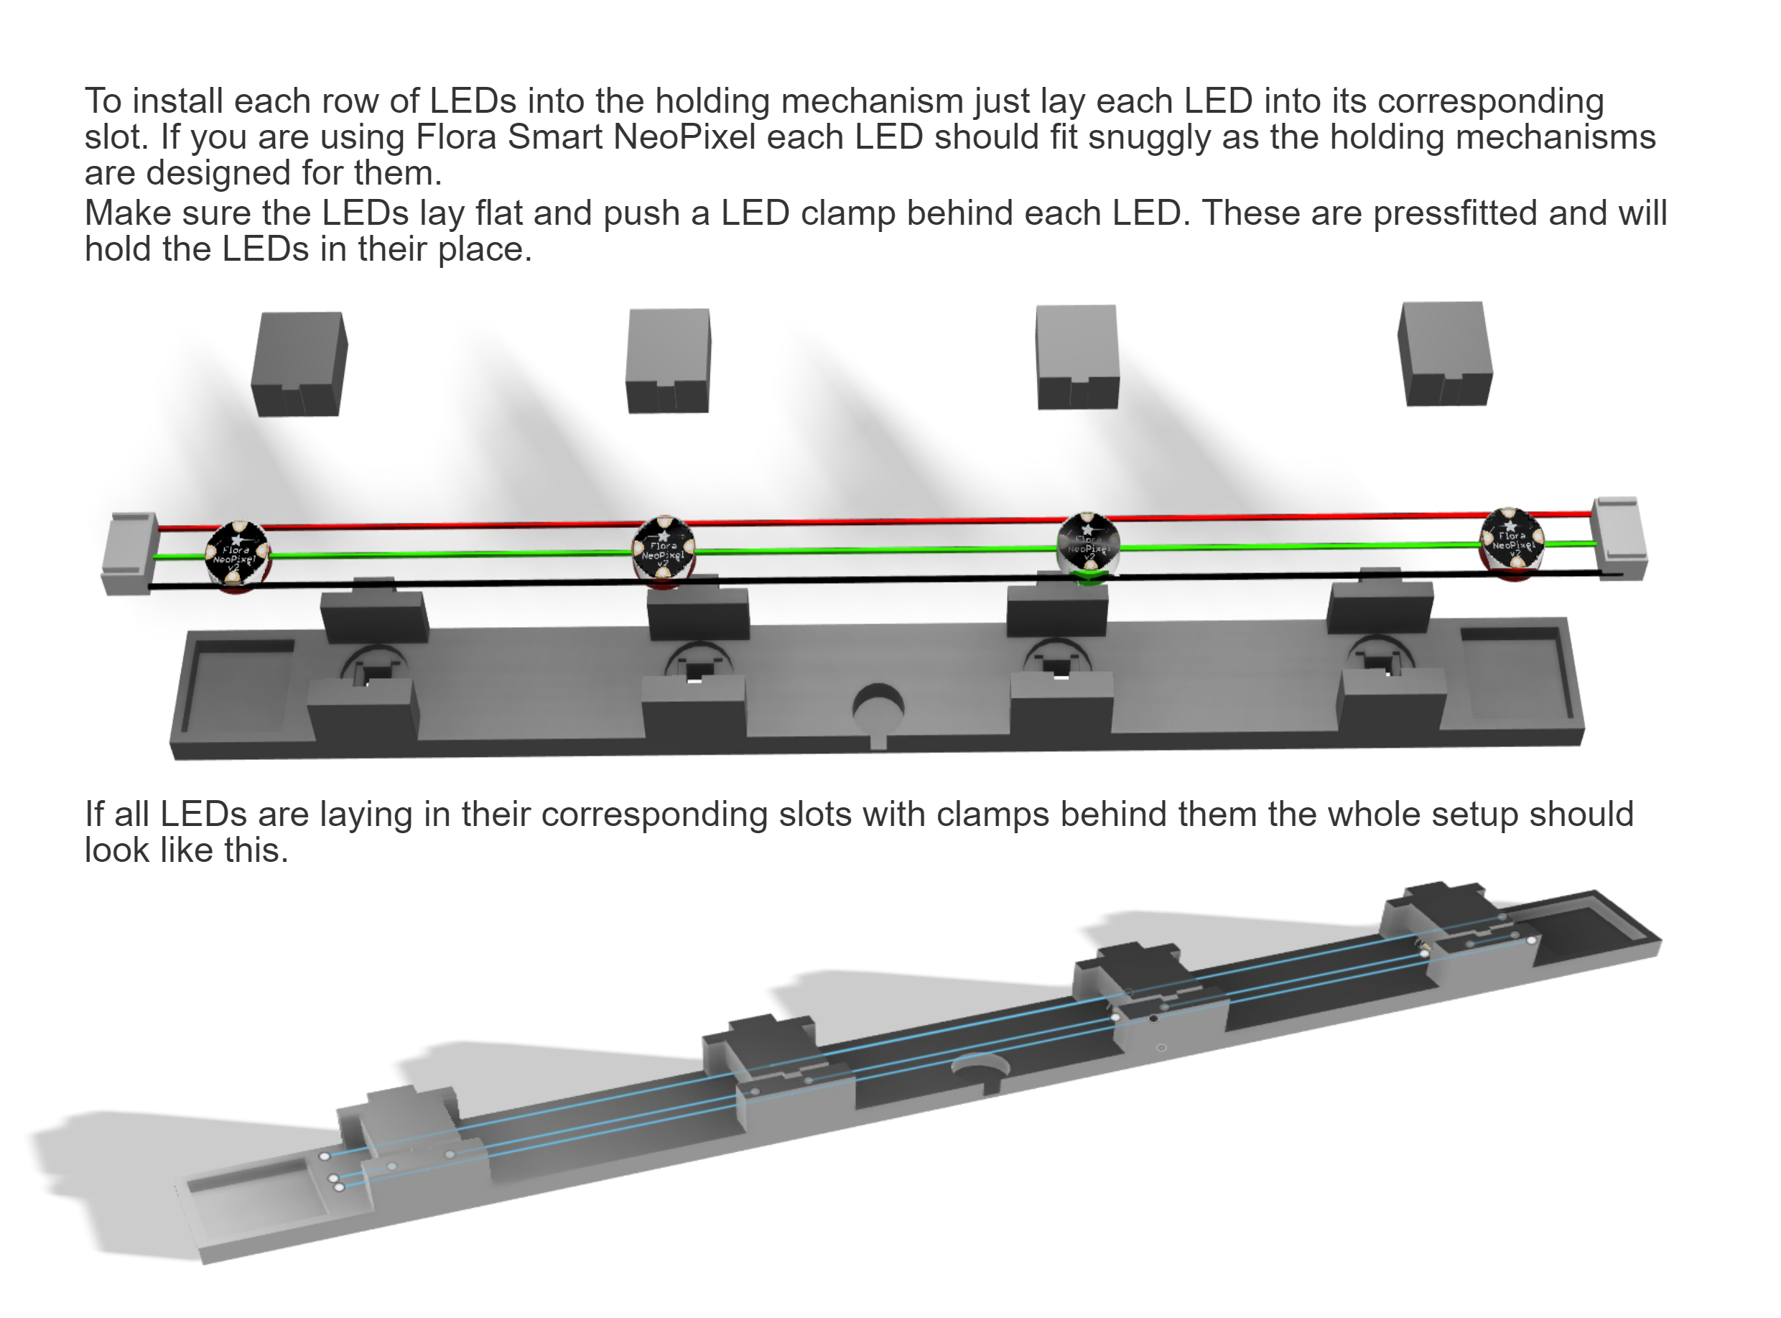

Assembly and attachment of acrylsheets and installing the holding mechanisms to the sparepartscontainer
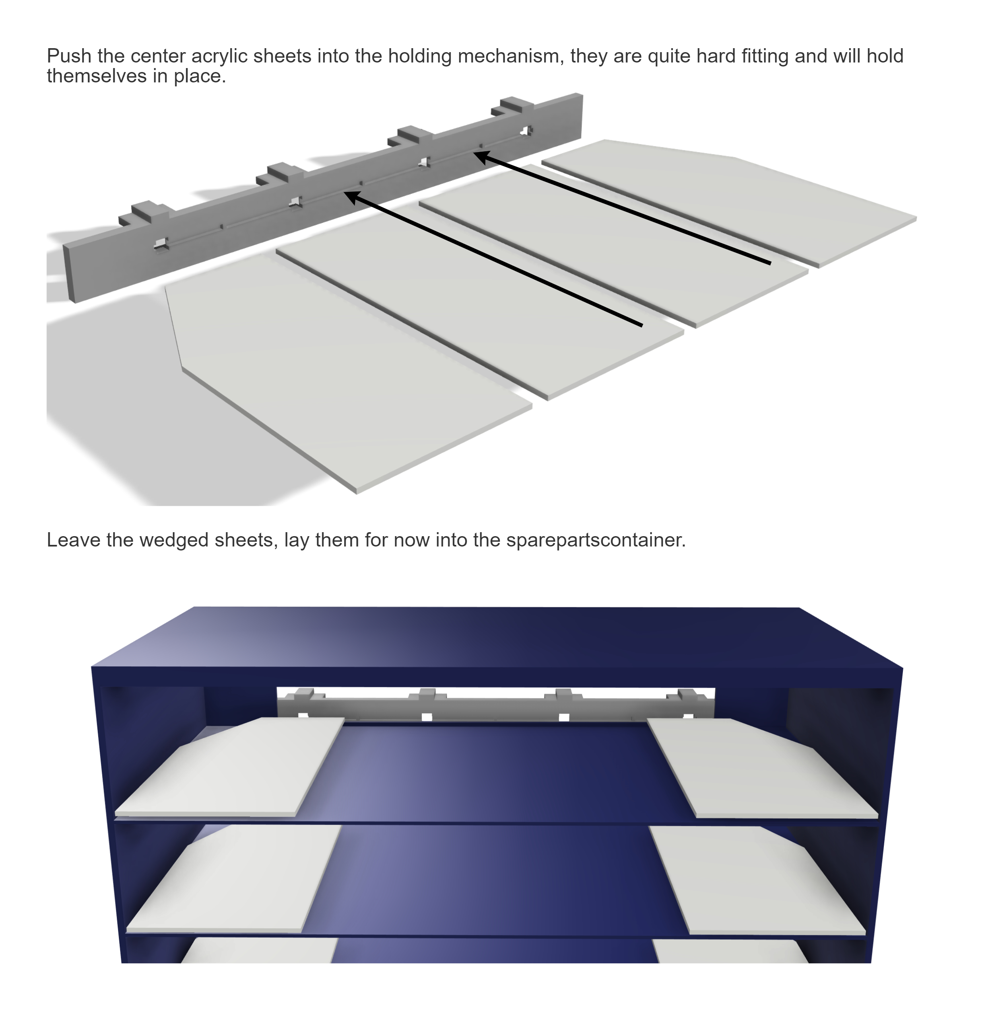
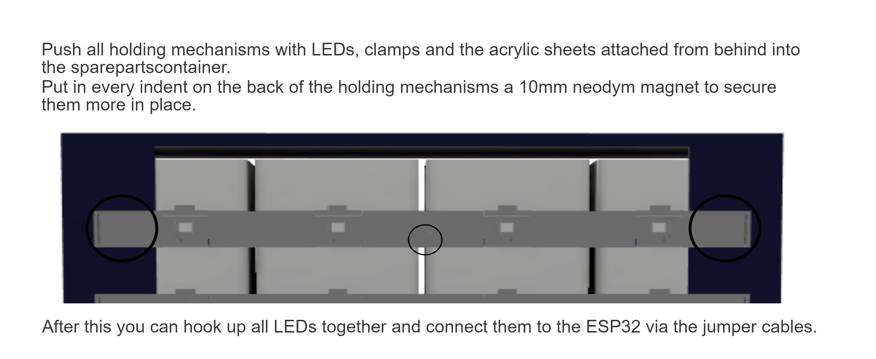

Testing

LEDs tested:

RGB Smart NeoPixel
Flora NeoPixel
"in house" LEDs

Best luminoscity/color purity: Flora NeoPixel

Cablelength tested: 10m before first LED, LEDs still working.

Nearly noticable difference between single and double LEDs per compartment.

Further information on the LEDs luminoscity can be found in the git repository.

